**Software Requirement Specification(SRS)**

**for**

**Online Marketing System**

**(Category)**

**1.Introduction**

**1.1. Purpose**

The goal of this product category or project(application) is intended to provide complete solutions for providers as well as customers through a single gate way using internet. It will enable providers to advertise their products by simply putting the name lists of the items under the product category, the customer to browse through the product category, and purchase them online without having to visit the shop physically.

**1.2 Scope**

**1.3 Definitions**

**Category:**

**1**. A class or division of shopping items regarded as having particular shared characteristics.

**2**. One of a possibly exhaustive set of classes among which all things might be distributed.

***Fashion:***

1. Men’s clothing

* Jeans fashion

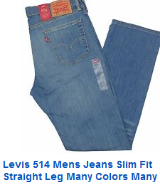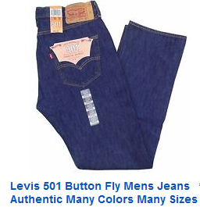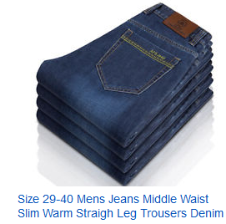

* Coats and jackets fashion
* Leather jackets and coats

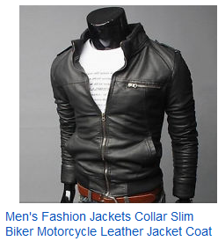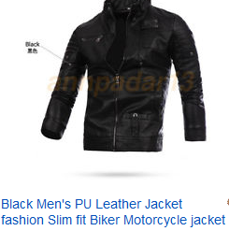

* Cotton jackets

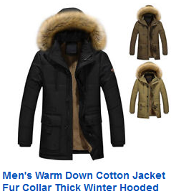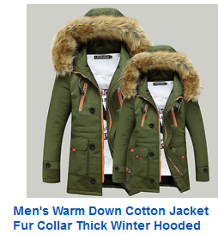

* Wool jackets and coats

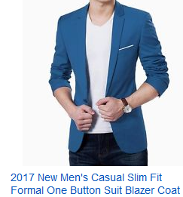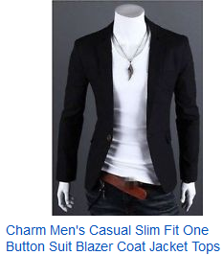

* Sweaters

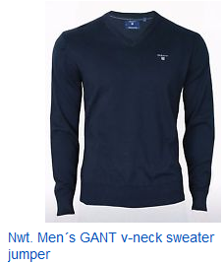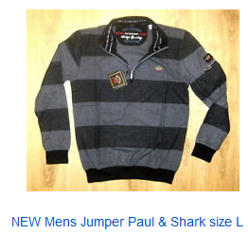

* T-Shirts

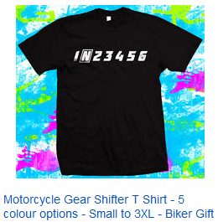 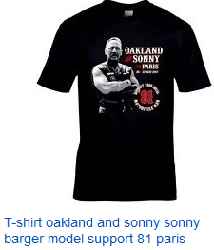

* Dress shirts

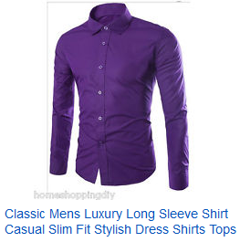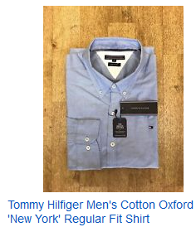

* Shoes
* Panties
* Socks
* Shorts
* ETC

1. Women’s clothing

* Jeans fashion

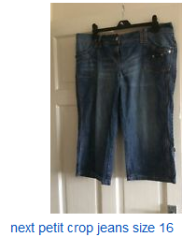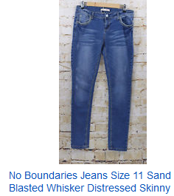

* T-Shirts fashion

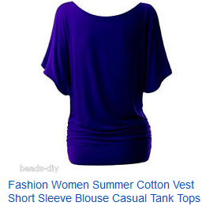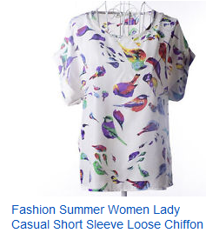

* Coats and jackets fashion

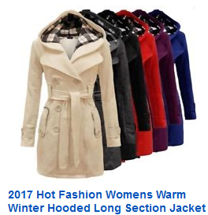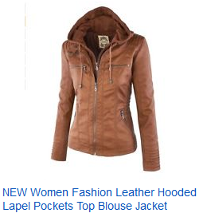

* Sweaters
* 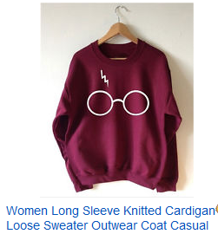
* Shoes
* Pants
* Socks
* Skirts
* 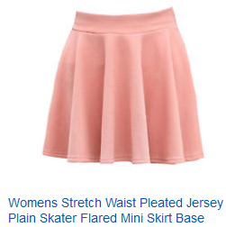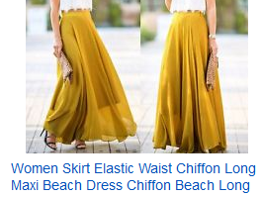
* Dresses

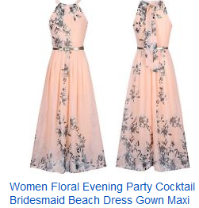

* Shorts
* ETC

1. Kid’s and baby’s clothing

* Boy’s clothing
* T-Shirts
* Sweaters
* Outerwear
* Underwear
* Shoes
* ETC
* Girl’s clothing
* Outerwear

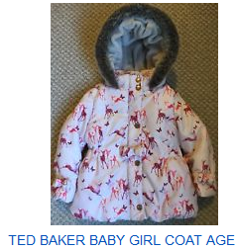

* Dresses
* Skirts
* Sweaters
* Underwear
* Shoes
* ETC
* Boy’s clothing (for newborn)
* T-Shirts
* Sweaters
* Outerwear
* Underwear
* ETC
* Girl’s clothing (for newborn)
* Outerwear

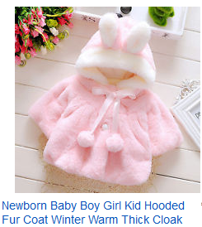

* Dresses
* Skirts
* Sweaters
* Underwear
* ETC

**1.4 Overview**

These categories provide an easy solution for customer to select and buy the products without any confusion and within a short time which is the same for provider to put/insert the products under corresponding categories easily and sale the product.

This can be used by any

**2. Overall Descriptions:**

The product category list database enables vendor to put his/her products under specific categories, and customer to browse through specific category lists to get his/her item.

**2.1 Product Perspective:**

**2.2 Product Functions:**

The product category system should support the following use cases:

**Use Case 1:** **uploading the products (putting items in to the system)**

**Primary Actor:** Seller

**Precondition:**

**Main Success Scenario:** When a provider uploads a product, the product should be inserted to the corresponding category.

-The product category list should be updated.

**Exception Scenarios (Failure Conditions):**

**Failure Handling:**

**Use Case 2: Selecting an item to buy**

**Primary Actor:** Buyer/Customer

**Precondition:** Registered and Login to the system

**Main Success Scenario:** When a buyer selects a product to buy it,

**Exception Scenarios:**

**Failure Handling:**

**Use Case 3: The buyer buys items or products**

**Primary Actor:** Buyer

**Precondition:**

**Main Success Scenario:**

**Failure Conditions:**

**Failure Handling:**

**2.3 User Characteristics:**

The user should know or first select the category under which an item he/she wants is found.

**2.4 General Constraints:**

**2.5 Assumptions and Dependencies:**

**3. Specific Requirements:**

**3.1 External Interfaces:**

* 1. **Functional Requirements:**

**3.3 Performance Requirements:**

In order to completely satisfy the customer’s interest of choice this product category should contains nearly each and every necessary product lists.

**3.4**

**3.5 Design Constraints:**

Non-fun&thec